Venous Thromboembolism (VTE) in Covid-19 Patients
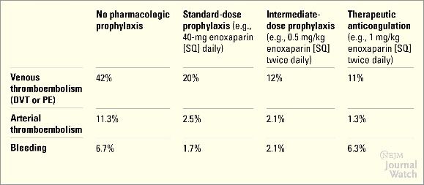
- VTE is a common in hospitalized covid-19 patients with and incidence risk of 42% in the absence of risk reduction.

- VTE is a preventable cause of mobility and motility in hospitalized patients with Covid-19
- Appropriate VTE prophylaxis can significantly mitigate the events of VTE
Risk factors for VTE in covid-19 patients
- Disease burden
  - Critical or acute illness
  - Hypoxia
  - Stasis
  - Fever
  - Diarrhea
  - Liver injury
  - Sepsis
  - CKD
  - COPD
  - HF
  - Malignancy
- Severe inflammatory response
  - Lymphopenia
  - Increase IL-6, CRP
- Increased D-dimer, fibrinogen, prolonged prothrombin and prothrombin time and mild thrombocytopenia

Management: Inpatient VTE prophylaxis
UIHC protocol (see page 2)

Guidelines: Summary of Recommendations
- American society of hematology (ASH)

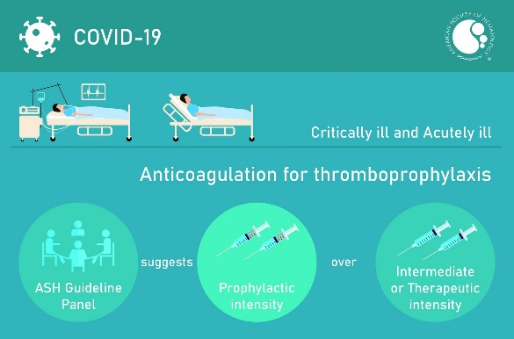

- CHEST Guideline: Thromboprophylaxis is recommended only during hospitalization. Extended thromboprophylaxis can be considered om the net benefit determined by the bleeding risk.

Other comments

Indication for full dose anticoagulation should be based of comprehensive clinical assessment

Management of bleeding associated with prophylactic anticoagulation should be well established.

Aspirin/antiplatelet agents have not been shown to improve outcome and use of aspirin increases bleeding risk

